**MINISTRY OF EDUCATION AND TRAINING**

**SCHOOL OF INFORMATION & COMMUNICATION TECHNOLOGY**

**🙞 🕮 🙜**

**MOBILE APPLICATION PROGRAMMING**

**Student name: Tran Dang Khoa**

**Student ID : B2014926**

**Courses: 46**

Can Tho, 01/2024

**Subject: Mobile programming (Android)**

**Lab 1. Introduction to ANDROID STUDIO**

refer (or any other link):

* <https://www.tutorialspoint.com/android/android_hello_world_example.htm>
* <https://developer.android.com/courses/android-basics-compose/unit-1>
* <https://developer.android.com/studio/intro/user-interface>

1. Android studio installation

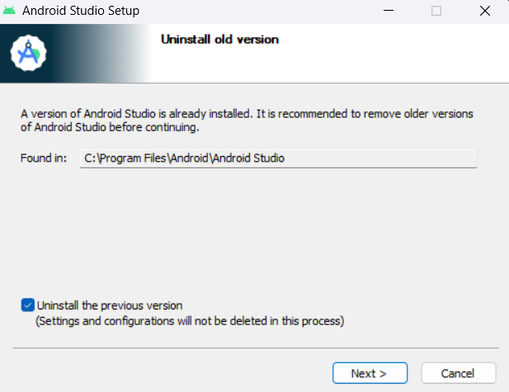

To install Android Studio, we need to download file installation from the original website, then open this file and install Android Studio as a normal window application.

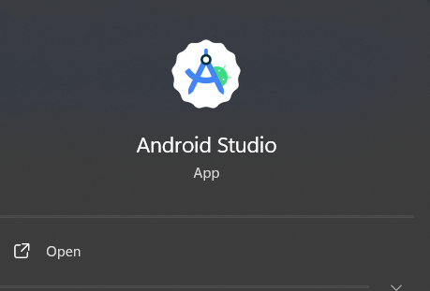

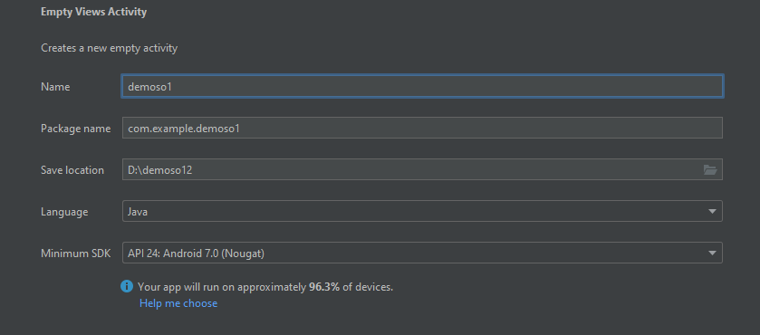

1. Components in an Android Project
   1. Activity:

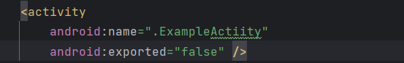

* + - An activity represents a single screen with a user interface,in-short Activity performs actions on the screen.
    - If an application has more than one activity, then one of them should be marked as the activity that is presented when the application is launched.
  1. Service:

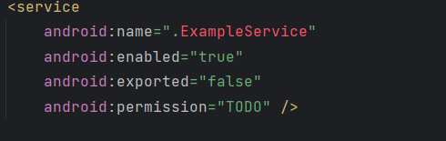

A service is a component that runs in the background to perform long-running operations.

* 1. Content provider:

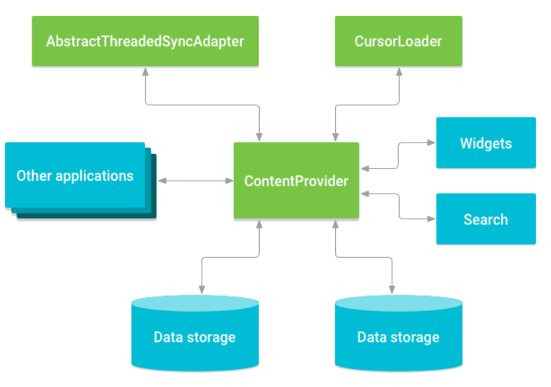

Broadcast Receivers simply respond to broadcast messages from other applications or from the system

* 1. Addications Components

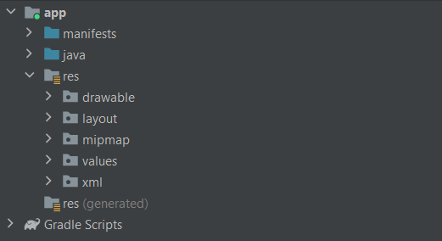

There are additional components which will be used in the construction of above mentioned entities, their logic, and wiring between them.

* 1. Intents:

It is a powerful inter-application message-passing framework. They are extensively used throughout Android. Intents can be used to start and stop Activities and Services, to broadcast messages system-wide or to an explicit Activity, Service or Broadcast Receiver or to request action be performed on a particular piece of data.

* 1. Widgets:

These are the small visual application components that you can find on the home screen of the devices. They are a special variation of [Broadcast Receivers](https://www.geeksforgeeks.org/broadcast-receiver-in-android-with-example/) that allow us to create dynamic, interactive application components for users to embed on their Home Screen.

1. Folders and files in an Android project (new project, select “Empty Views Activity”)

First app: <https://developer.android.com/training/basics/firstapp>

Code: A simple app to introduce your info

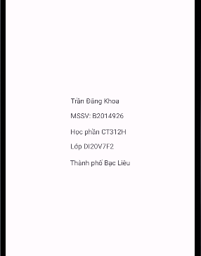

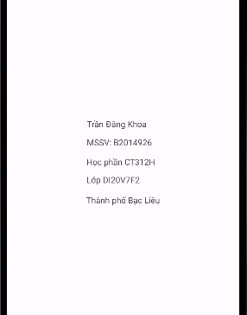

**Lab 2. LAYOUT and Resolutions**

Refer:

* <https://developer.android.com/guide/topics/ui/declaring-layout>
* <https://developer.android.com/training/constraint-layout>

* <https://www.tutorialspoint.com/android/android_user_interface_layouts.htm>

* <https://developer.android.com/training/multiscreen/screendensities>

1. Introduction to layouts (Constraint, Linear, Table,..)

A layout defines the structure for a user interface in your app, such as in an [activity](https://developer.android.com/guide/components/activities). All elements in the layout are built using a hierarchy of [View](https://developer.android.com/reference/android/view/View) and [ViewGroup](https://developer.android.com/reference/android/view/ViewGroup) objects. A View usually draws something the user can see and interact with. A ViewGroup is an invisible container that defines the layout structure for View and other ViewGroup objects.

View objects are often called widgets and can be one of many subclasses, such as [Button](https://developer.android.com/reference/android/widget/Button) or [TextView](https://developer.android.com/reference/android/widget/TextView). The ViewGroup objects are usually called layouts and can be one of many types that provide a different layout structure, such as [LinearLayout](https://developer.android.com/reference/android/widget/LinearLayout) or [ConstraintLayout](https://developer.android.com/reference/androidx/constraintlayout/widget/ConstraintLayout).

There are two ways to declare a layout:

Declare UI elements in XML. Android provides a straightforward XML vocabulary that corresponds to the View classes and subclasses, such as those for widgets and layouts.

Instantiate layout elements at runtime. Your app can create View and ViewGroup objects and manipulate their properties programmatically.

XML layout attributes named layout_something define layout parameters for the View that are appropriate for the ViewGroup it resides in.

Every ViewGroup class implements a nested class that extends [ViewGroup.LayoutParams](https://developer.android.com/reference/android/view/ViewGroup.LayoutParams). This subclass contains property types that define the size and position of each child view, as appropriate for the view group. As shown in figure 2, the parent view group defines layout parameters for each child view, including the child view group.

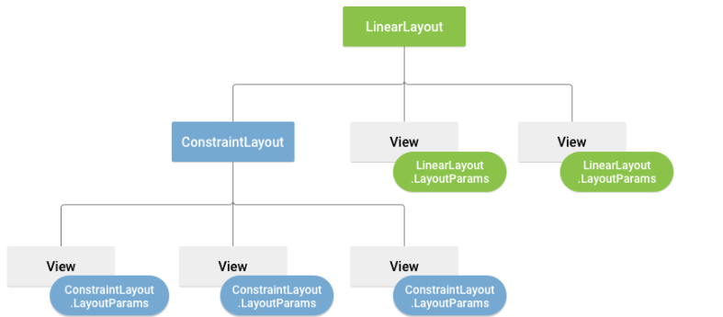

1. Introduction to resolutions (dp, dpi, hdpi,...)

Code: Design a mini calculator (just for the interface, don't need event handler)

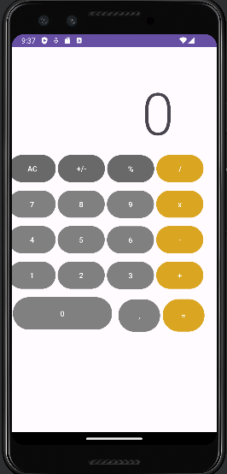

**Lab 3: Event handling (1): TEXTVIEW, EDITTEXT, BUTTON**

References:

* <https://www.tutorialspoint.com/android/android_event_handling.htm>
* <https://www.geeksforgeeks.org/event-handling-in-android/>

**Write report**

**OnClickListener()**

This is called when the user either clicks or touches or focuses upon any widget like button, text, image etc. You will use onClick() event handler to handle such event.

**OnLongClickListener()**

This is called when the user either clicks or touches or focuses upon any widget like button, text, image etc. for one or more seconds. You will use onLongClick() event handler to handle such event.

**OnFocusChangeListener()**

This is called when the widget looses its focus ie. user goes away from the view item. You will use onFocusChange() event handler to handle such event.

**OnFocusChangeListener()**

This is called when the user is focused on the item and presses or releases a hardware key on the device. You will use onKey() event handler to handle such event.

**OnTouchListener()**

This is called when the user presses the key, releases the key, or any movement gesture on the screen. You will use onTouch() event handler to handle such event.

**OnMenuItemClickListener()**

This is called when the user selects a menu item. You will use onMenuItemClick() event handler to handle such event.

**onCreateContextMenuItemListener()**

This is called when the context menu is being built(as the result of a sustained "long click)

**Design a simple app to perform Event handling using 2 methods.**

* 2 text box (a, b)
* 5 buttons: +, -, *, / and combine a&b (e.g., a = 5 and b = 7: a&b = 57)

A-B:

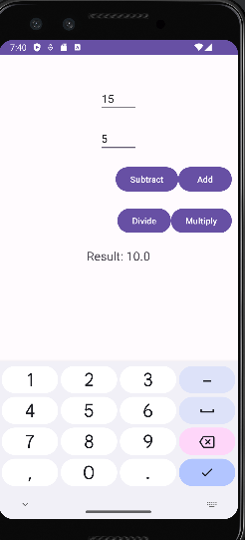

A+B:

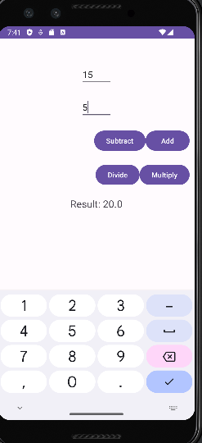

A/B:

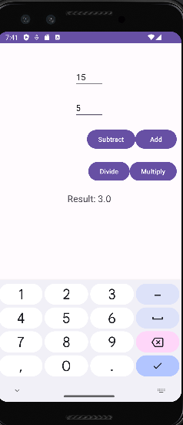

A*B:

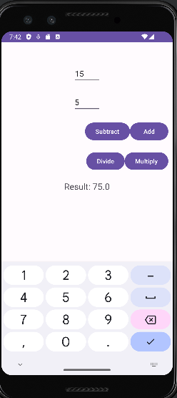

**Lab 4: Event handling (2): RADIO BUTTON, CHECKBOX, TOAST and IMAGEBUTTON**

References:

- <https://www.tutorialspoint.com/android/android_user_interface_controls.htm>

Write your report

There are number of UI controls provided by Android that allow to build the graphical user interface for the app.

|  |  |
| --- | --- |
| **UI Control** | **Description** |
| TextView | The control is used to display text to the user |
| RadioButton | Radio buttons let the user select one option from a set of mutually exclusive options. Use radio buttons if the user needs to see all available options listed. If it's not necessary to show all options, use a spinner instead. A RadioButton has two states: either checked or unchecked. |
| CheckBox | Checkboxes let the user select one or more options from a set. It suitable when presenting users with a group of selectable options that are not mutually exclusive. |
| ImageButton | An ImageButton is an AbsoluteLayout which enables to specify the exact location of its children. This shows a button with an image (instead of text) that can be pressed or clicked by the user. |

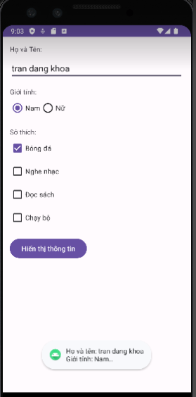

**Lab 5: Progress test 1**

English status app

* Student ID (textview + edittext)
* Class (textview + [Spinner](https://www.tutorialspoint.com/android/android_spinner_control.htm))
* Full name (textview + edittext)
* Gender (Radio button)
* birthDate (date picker), [example](https://www.tutorialspoint.com/android/android_datepicker_control.htm)
* English status:
  + Completed 3 English courses (checkbox)
  + Have B2 certificate (checkbox)
  + Have not completed (checkbox)

OK, CANCEL (button)

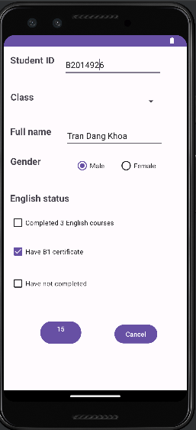

**Lab 6: Event handler (3): LISTVIEW**

References:

* <https://www.tutorialspoint.com/android/android_list_view.htm>
* <https://abhiandroid.com/ui/listview>

Ex1: reproduce the app at <https://xuanthulab.net/su-dung-listview-hien-thi-du-lieu-dang-danh-sach-trong-android.html>

**Introduction:**

Android ListView is a view which groups several items and display them in vertical scrollable list. The list items are automatically inserted to the list using an Adapter that pulls content from a source such as an array or database.

An adapter actually bridges between UI components and the data source that fill data into UI Component. Adapter holds the data and send the data to adapter view, the view can takes the data from adapter view and shows the data on different views like as spinner, list view, grid view etc.

The ListView and GridView are subclasses of AdapterView and they can be populated by binding them to an Adapter, which retrieves data from an external source and creates a View that represents each data entry.

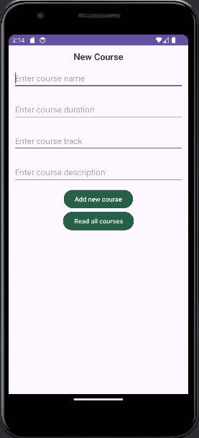

* The results of the entered information:

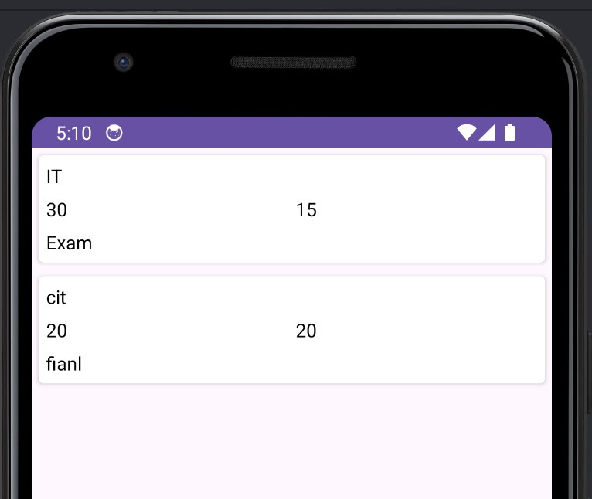

Ex2: Modify the Lab 6 to store all information to a listview and display them.

**Lab 7: Custom listview**

[**https://www.youtube.com/watch?v=po3EET8uK0g**](https://www.youtube.com/watch?v=po3EET8uK0g)

[**https://www.tutorialspoint.com/how-to-implement-a-long-click-listener-on-a-android-listview**](https://www.tutorialspoint.com/how-to-implement-a-long-click-listener-on-a-android-listview)

[**https://www.tutorialspoint.com/how-to-dynamically-remove-items-from-listview-on-a-click**](https://www.tutorialspoint.com/how-to-dynamically-remove-items-from-listview-on-a-click)

Using the Lab7 app, delete an item in the listview when long pressing the item (long click). You should use context menu to display “Delete”: [**https://www.javatpoint.com/android-context-menu-example**](https://www.javatpoint.com/android-context-menu-example)

**Lab 8: SQLite database**

**Introduction:**

SQLite is an open-source database management system, also known as a compact relational database system, different from other management systems such as MySQL, SQL Server, Ocracle, PostgreSQL... SQLite is a software library that deploys a traditional SQL Database Engine, does not need a client-server model, we don't need to establish any kind of connections. It is an embedded SQL database system, can be used immediately without configuration, without needing a separate SQL Server so it is very compact. Also, SQLite is widely used on many platforms (Mobile, Desktop, Webserver...).

**Refer:**

* <https://www.tutorialspoint.com/android/android_sqlite_database.htm>
* <https://abhiandroid.com/database/sqlite>
* <https://abhiandroid.com/database/add-retrieve-image-sqlite-database-example-android-studio.html>
* <https://xuanthulab.net/su-dung-sqlite-trong-android-phan-1.html>

<https://github.com/xuanthulabnet/android-sqlite-example1>

* <https://www.javatpoint.com/android-sqlite-tutorial>

Reproduce the app in the following links:

* Create and Add Data to SQLite Database:

<https://www.geeksforgeeks.org/how-to-create-and-add-data-to-sqlite-database-in-android/>

* Read Data from SQLite Database

<https://www.geeksforgeeks.org/how-to-read-data-from-sqlite-database-in-android/?ref=rp>

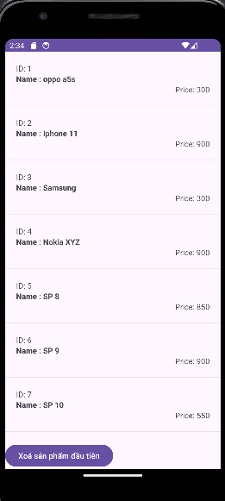

**Lab 9: SQLite database (2)**

* Delete Data in SQLite Database in Android

[**https://www.geeksforgeeks.org/how-to-delete-data-in-sqlite-database-in-android/?ref=rp**](https://www.geeksforgeeks.org/how-to-delete-data-in-sqlite-database-in-android/?ref=rp)

* Update Data to SQLite Database in Android

[**https://www.geeksforgeeks.org/how-to-update-data-to-sqlite-database-in-android/?ref=rp**](https://www.geeksforgeeks.org/how-to-update-data-to-sqlite-database-in-android/?ref=rp)

**Lab 10: Progress test 2**

Thiết kế phần mềm quản lý ghi chú tương tự như hình, lưu vào csdl sqlite. Cho phép thêm, sửa, xóa ghi chú.

* Tiêu đề
* Nội dung
* Thời gian (ngày, giờ)

Khi ấn lâu vào mục ghi chú nào, menu ngữ cảnh (xem lại Lab 8) hiện ra cho phép chọn Xóa hoặc Sửa 1 ghi chú.

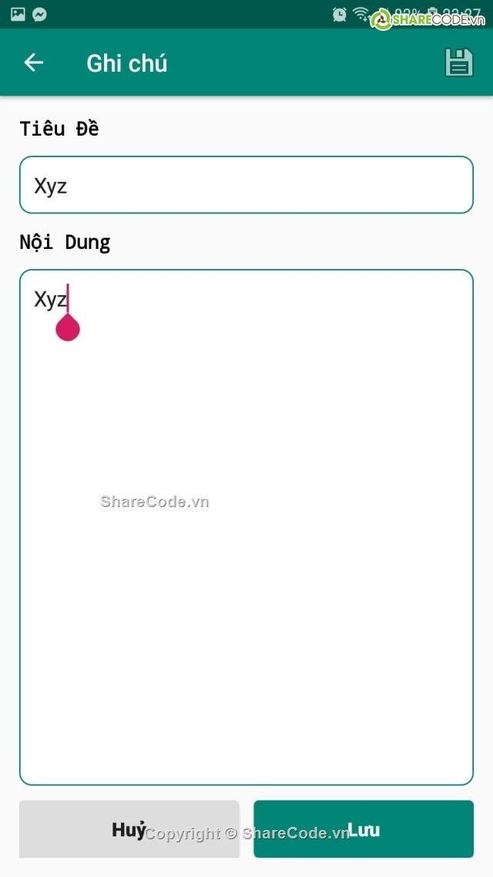**.   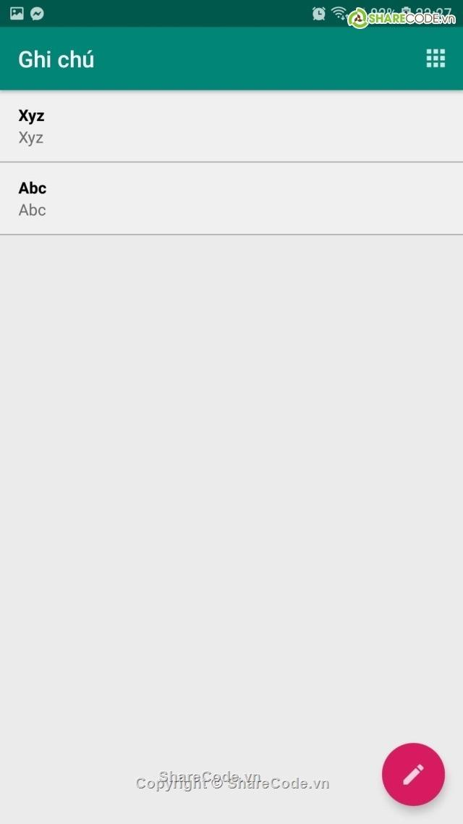**

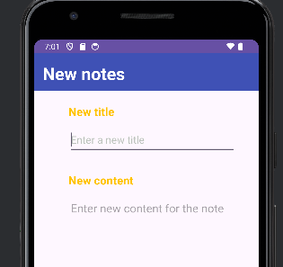

* Enter the information:

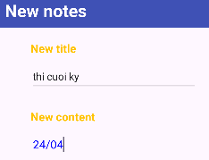

**Lab 11: Google Firebase database**

Video <https://www.youtube.com/watch?v=wa8OrQ_e76M>

Reproduce all the examples in the following links:

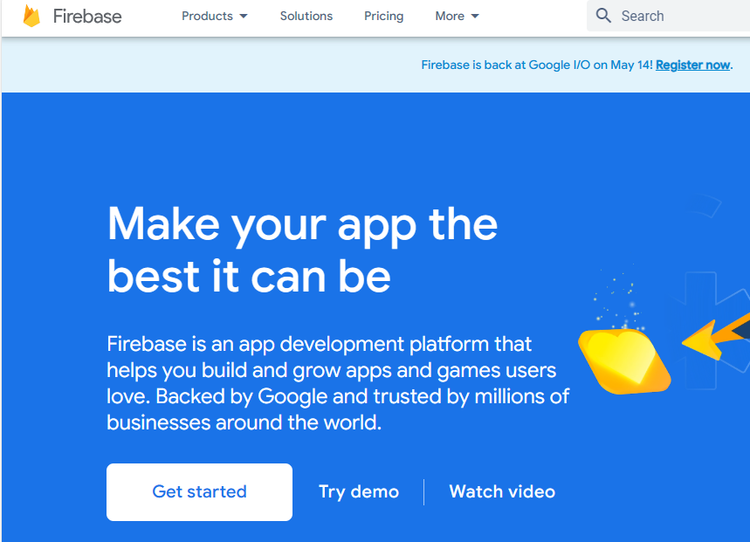

* Click "Get Start" to get started:



* Then, select "Add Project" to continue:

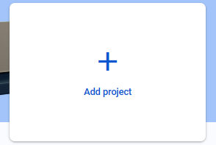

* Enter the name of the project:

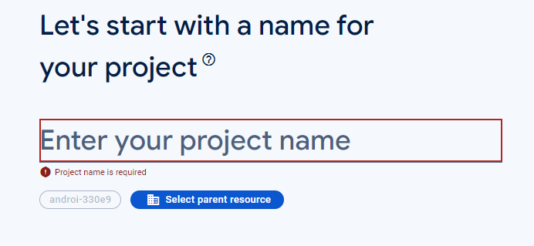

* Select continue:

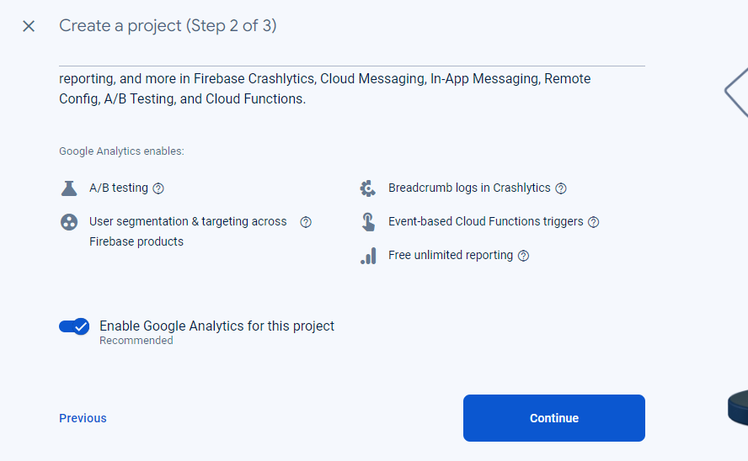

* Complete project creation

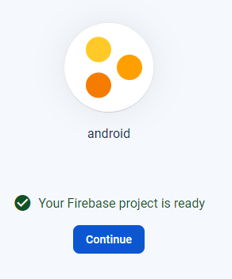

* Then go back to "Android Studio" and use the selection Tool – Firebase

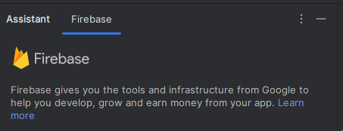

* Select "Realtime Database" - Get started with Realtime Database (Java):

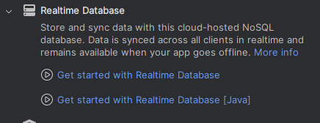

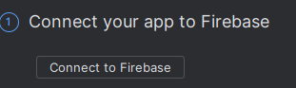

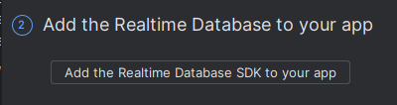

**Lab 12: Progress Exercise: Implementation, Demo & presentation**

Building simple apps such as English vocabulary management, Electric/Water Management, Car/Motorbike maintenance management, Cafeshop management,… (using SQLite or Firebase)

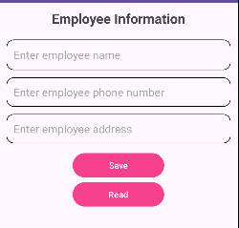

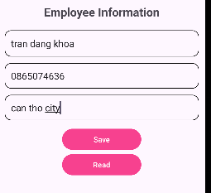

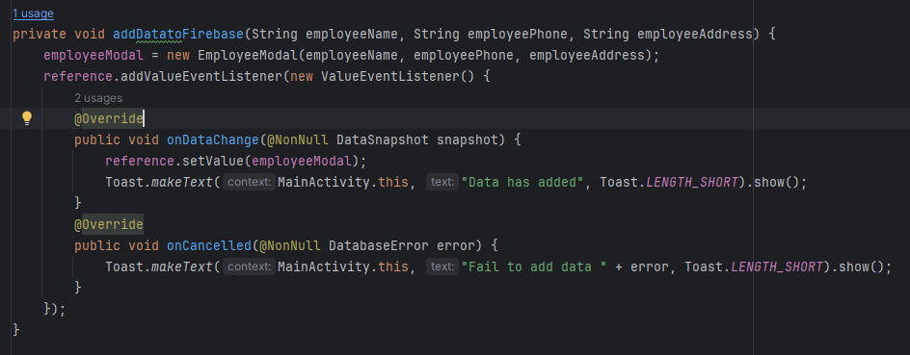

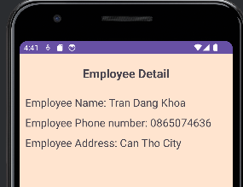

LAB13

